

2023
Year 11 Integrated Science – Unit 2: Physical Science
Task 9: Physics Test
Assessment Type: |  | Name:
Test
Duration & Conditions:  Test conditions |  | Teacher:
45 minutes
Assessment weighting:  5 % of year mark |  | Date:

Section | Marks
Part one: multi-choice | $${}/{10}$$
Part two: Short Answer | $${}/{35}$$
Total Mark | $${}/{45}$$

I acknowledge that all the information contained in this task is my own work and not taken from other sources. If other sources have been used, they have been acknowledged in my references.
___________________________________
(Student Signature)

Please see SEQTA for Teacher feedback and comments

PART ONE: MULTI-CHOICE
- A car is slowing down on a level road. There must be:
  - no forces acting on it.
  - only a backwards force acting on it.
  - a net backwards force acting on it.
  - a net forwards force acting on it.

- A cyclist rides a hilly course between points P and U, as shown in the diagram to the right. The point that the rider has the most potential energy is.
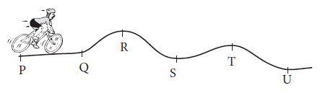
  - R
  - S
  - T
  - U

- According to Newton’s 1st Law of Motion, a moving object that is not acted on by an unbalanced force will:
  - maintain its velocity.
  - accelerate.
  - eventually come to a stop.
  - transfer its kinetic energy into potential energy.

- Alinta is jumping straight up and down on a trampoline. Which of the following best describes the energy changes occurring when she falls from maximum height back down onto the trampoline?
  - elastic potential energy → gravitational potential energy → kinetic energy
  - gravitational potential energy → kinetic energy → elastic potential energy
  - kinetic energy → gravitational potential energy → elastic potential energy
  - elastic potential energy → thermal energy → kinetic energy

- Which of the following is best explained by Newton’s first law?
  - unbelted passengers will be thrown forward when a car stops suddenly
  - a gun recoils when a shot is fired
  - the acceleration of an object when a force is applied depends on the mass of the object
  - the weight of an object varies from planet to planet

- Which of the following is best explained by Newton’s second law?
  - unbelted passengers will be thrown forward when a car stops suddenly
  - a gun recoils when a shot is fired
  - the acceleration of an object when a force is applied depends on the mass of the object
  - the weight of an object varies from planet to planet

- Which of the following is best explained by Newton’s third law?
  - unbelted passengers will be thrown forward when a car stops suddenly
  - a gun recoils when a shot is fired
  - the acceleration of an object when a force is applied depends on the mass of the object
  - the weight of an object varies from planet to planet

- A moving object has an applied force of 50 N forwards and a total frictional force of 40 N. The net force will be:
  - 90 N backwards.
  - 90 N forwards.
  - 10 N forwards.
  - 10 N backwards.

- When the forces on an object are unbalanced, what can be said about its motion?
  - Its velocity may increase or decrease in magnitude.
  - It may change direction.
  - It will maintain its current velocity.
  - Both a and b.

- Which of these options would increase the friction experienced by an object sliding on a surface?
  - Making the surface smoother.
  - Increasing the mass of the object.
  - Decreasing the velocity of the object.
  - Adding a lubricant like oil or water.

PART TWO: SHORT ANSWER
- A cart is pushed along a smooth surface then released. Draw labelled free body diagrams to show the forces acting on the cart: (6 marks)
When the cart is being pushed, before it starts moving
After the push, while the cart is still moving
After it has stopped

N
N
N
F_{f}
F_{A}

W
W
W

Box 1: 1 for correct forces, 1 for correct directions, take off mark for extra forces
Box 2: 1 for correct forces, 1 for correct directions, take off mark for extra forces
Box 3: 1 for correct forces, 1 for correct directions, take off mark for extra forces

- A 1000 kg car travelling at 60 km/h north collides with a 5000 kg truck travelling at 60 km/h east.

- Circle the vehicle that experiences more force. Explain your answer using Newton’s Laws. (3 marks)

Answer: both experience the same (1 mark)
Explanation: Newton’s 3rd Law (1 mark)
Equal and opposite forces (1 mark)

- Circle the vehicle that experiences more acceleration. Explain your answer using Newton’s Laws. (3 marks)

Answer: the car (1 mark)
Explanation: Newton’s 2rd Law (1 mark)
The car has less mass. Same force and less mass more acceleration (1 mark)

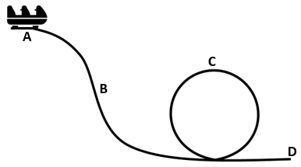
- A rollercoaster is stationary at the top of the track. Using the diagram below and assuming that there is no friction or wasted energy, circle the correct answer to the following questions. (3 marks)

- Where does the cart have the highest gravitational potential energy?
A B C D All points are the same
- Where does the cart have the highest kinetic energy?
A B C D All points are the same
- Where does the cart have the highest total energy?
A B C D All points are the same

- A 0.2 kg ball is dropped from 5 m above the ground. Assume there is no air resistance.

- Calculate the potential energy of the ball when it is dropped. (2 marks)
PE = mgh = 0.2 * 10 * 5 = 10 J (1 for substitution, 1 for answer)

- What is the kinetic energy of the ball when it hits the ground? (1 mark)
KE = 10 J
- Calculate the kinetic energy of the ball when it is 2.5 m above the ground. (2 marks)
Total energy = 10 J
PE at 2.5m above ground = 0.2*10*2.5 = 5 J
KE at 2.5m above ground = Total energy - PE at 2.5m above ground = 10 – 5 = 5 J
(1 for working, 1 for answer)

- When it bounces, the ball does not return to its original height. Explain why not. (2 marks)

Energy is lost due to sound, heat, etc (1 mark)
This reduces the total energy of the ball, stopping it from reaching its original height (1 mark)

- A cyclist is moving along a flat road with forces shown in the diagram below. The total mass of the cyclist and their bike is 70 kg.
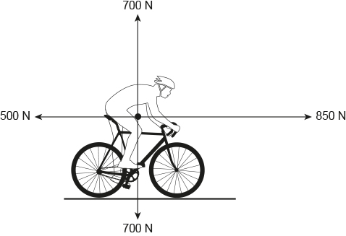

- Calculate the net force acting on the cyclist. (1 mark)
850 – 500 = 350 N to the right

- State how the motion of the cyclist will change. (1 mark)
Accelerating to the left
- Calculate the acceleration of the cyclist. (2 marks)

F = ma = 70 * a = 350 (1 mark)
a = 5 m/s² to the right (1 mark)

- The cyclist was originally travelling at 10 m/s. Calculate their velocity after they accelerate for 4 seconds. (3 marks)

Acceleration = change in velocity / time = 5 = change in velocity / 4 (1 mark)
Change in velocity = 20 m/s (1 mark)
Final velocity = 10 m/s + 20 m/s = 30 m/s (1 mark)

- A skydiver jumps out of a plane, falls for a period then opens their parachute. Explain why their velocity decreases when they open the parachute. (3 marks)

Air resistance increased when the parachute was opened (1 mark)
This resulted in a net force upwards (1 mark)
This caused an acceleration upwards (1 mark)

- When a person slides on ice, they can travel much further than when they slide on sand. Explain why, including a description of the forces acting on the person. (3 marks)

Friction is higher on sand than ice (1 mark)
This means there is a higher force opposing their motion (1 mark)
They decelerate faster and do not travel as far (1 mark)

END OF ASSESSMENT

